**LOCATION TELLER APP**

**A Minor Project Report**

Submitted To



**Chhattisgarh Swami Vivekanand Technical University**

**Bhilai, India**

For

The partial fulfillment of Degree

of

**Bachelor of Technology**

*in*

**Computer Science & Engineering**

By -

**Diksha Chandrakar**

**Roll No**. – 303302218030

**Enrollment No.** – BF4722

7th Semester

Under the Guidance of

**Mr. Santanu Mukherjee**

Assistant Professor

Department of Computer Science & Engineering

S.S.I.P.M.T, Raipur

**__________________________________________________________**



**Department of Computer Science & Engineering**

**Shri Shankaracharya Institute of Professional Management & Technology**

**Raipur (C.G.)**

**_________________________________________________________**

**Session: 2021 - 2022**

**DECLARATION BY THE CANDIDATE**

I the undersigned solemnly declare that the Minor project report entitled **“LOCATION TELLER APP ”** is based on my own work carried out during the course of our study under the supervision of **Mr. Santanu Mukherjee *.***

I assert that the statements made and conclusions drawn are an outcome of the project work. I further declare that to the best of our knowledge and belief that the report does not contain any part of any work which has been submitted for the award of any other degree/diploma/certificate in this University/Deemed university of India or any other country.

____________________________

(Signature of Student )

**Diksha Chandrakar**

**Roll No**. – 303302218030

**Enrollment No.** – BF4722

7th Semester

(Signature of the Supervisor)

**Mr. Santanu Mukherjee**

Assistant Professor

Department of Computer Science & Engineering

S.S.I.P.M.T, Raipur

**CERTIFICATE BY THE SUPERVISOR**

This is to certify that the Minor project report entitled **“LOCATION TELLER APP”** is a record of project work carried out under my guidance and supervision for the fulfillment of degree of Bachelor of Technology in the faculty of Computer Science & Engineering of Chhattisgarh Swami Vivekananda Technical University, Bhilai (C.G.) India.

To the best of my knowledge and belief the report

1. Embodies the work of the candidate himself
2. Has duly been completed
3. Fulfills the partial requirement of the ordinance relating to the B.E. degree of the University
4. Is up to the desired standard both in respect of contents and language for being referred to the examiners.

__________________________

(Signature of the Supervisor)

**Mr. Santanu Mukherjee**

Assistant Professor

Dept. of CSE

S.S.I.P.M.T, Raipur

Forwarded to Chhattisgarh Swami Vivekanand Technical University

Bhilai

_______________________________

(Signature of HOD)

Dept. of Computer Science & Engineering

S.S.I.P.M.T

Raipur, C.G

_______________________________

(Signature of the Principal)

**Dr. Alok Kumar Jain**

S.S.I.P.M.T

Raipur, C.G

**CERTIFICATE BY THE EXAMINERS**

The project report entitled **“LOCATION TELLER APP**“has been examined by the undersigned as a part of the examination of Bachelor of Technology in the faculty of Computer Science & Engineering of Chhattisgarh Swami Vivekanand Technical University, Bhilai.

__________________ __________________

**Internal Examiner External Examiner**

**Date: Date:**

**Acknowledgement**

Working for this project has been a great experience for us. There were moments of anxiety, when we could not solve a problem for the several days. But we have enjoyed every bit of process and are thankful to all people associated with us during this period we convey our sincere thanks to our project guide **Mr. Santanu Mukherjee** for providing me all sorts of facilities. His support and guidance helped us to carry out the project. We owe a great dept. of his gratitude for his constant advice, support, cooperation & encouragement throughout the project we would also like to express our deep gratitude to respected **Dr. J P Patra** (Head of Department) for his ever helping and support. We also pay special thanks for his helpful solution and comments enriched by his experience, which improved our ideas for betterment of the project. We would also like to express our deep gratitude to respected **Dr. Alok Kumar Jain** (Principal) and college management for providing an educational ambience. It will be our pleasure to acknowledge, utmost cooperation and valuable suggestions from time to time given by our staff members of our department, to whom we owe our entire computer knowledge and also we would like to thank all those persons who have directly or indirectly helped us by providing books and computer peripherals and other necessary amenities which helped us in the development of this project which would otherwise have not been possible.

**Diksha Chandrakar**

**Roll No**. – 303302218030

**Enrollment No.** – BF4722

7th Semester

|  |  |  |
| --- | --- | --- |
|  |  |  |

**List of Abbreviations**

|  |  |
| --- | --- |
| **OS** | Operating System |
| **GPS** | Global Positioning System |
| **GPRS** | General Packet Radio Service |
| **LBS** | Location Based Service |
| **ID** | Identity |
| **API** | Application Programming Interface |

**List of Figures**

|  |  |  |  |
| --- | --- | --- | --- |
| Sr.No. | Figure No. | Description | Pg No. |
| 1. | Fig. 1 | Architecture of GPS System | 17 |
| 2. | Fig. 2 | Android location API | 19 |
| 3. | Fig. 3 | Google Map | 20 |
| 4. | Fig. 4 | JAVA Logo | 22 |
| 5. | Fig. 5 | Incremental Model | 26 |
| 6. | Fig. 6 | Features of SRS | 27 |
| 7. | Fig. 7 | Work Flow Diagram | 33 |
| 8. | Fig. 8 | Level 0 DFD | 35 |
| 9. | Fig. 9 | Image 1 | 37 |
| 10. | Fig. 10 | Image 2 | 38 |
| 11. | Fig. 11 | Image 3 | 39 |
| 12. | Fig. 12 | Image 4 | 40 |
| 13. | Fig. 13 | Image 5 | 41 |
| 14. | Fig. 14 | Image 6 | 42 |
| 15. | Fig. 15 | Image 7 | 43 |

**Table of Contents**

Chapter Title Page No.

ABSTRACT ………………………………………………………………...9

1 INTRODUCTION…………………………………………………………..11

1.1 Over View ……………………………………………………………..12

1.1.1 Applications ………………………………………………………...13

2 LITERATURE REVIEW …………………………………………………..14

2.1 Mobile Phone Service Provider …………………………………..16

2.2 Satellite ……………………………………………………………...16

2.3 GPS ……………………………………………………………….......17

2.4 Android Location API ………………………………………………18

2.5 Android Phone ………………………………………………………19 2.6 Google Map ……………………………………………………………20

3 METHODOLOGY ………………………………………………………. 21

3.1 JAVA ………………................................................................................22

3.2 Android Studio …………………… …. …………………………..23

3.3 APK Bundle …………………………………………………………… 24

3.4 Incremental Model …………………………………………………. 25

3.5 Software Analysis ……………………………………………………. 27

4 PROJECT REQUIREMENTS …………………………………………….28

4.1 Developer’s End ……………………………………………………….29

4.2 End User ………………………………………………………… .. ….. 30

5 DIAGRAMS ………………………………………………….. ………….31

5.1 Work Flow Diagram ………………………………………………..32

5.2 Data Flow Diagram ……………………………………………….. 34

6 SNAPSHOTS OF THE PROJECT ……………………………………… 36

7 RESULT ……………………………………………………………………. 45

7.1 Conclution …………………………………………………………… 46

7.2 Future Scope ………………………………………………………… 47

7.3 Limitation ……………………………………………………………. 48

8 REFERENCES …………………………………………………………… 49

9 PAPER PUBLICATION ……………………………………………………… 50

**ABSTRACT**

This project presents an implementation of a location-based service developed for android devices. It also covers a review of the need for location-based services and methods of location acquisition, which include GPS, cell-stations, wireless access point and IP address based Geo location lookup positioning. It covers a review of contemporary technologies for development of software systems based on location-based services and their use on android devices. The presented implementation demonstrates an example of a GPS designed to provide venue information based on location information of Android operating system driven phones .As the android GPS is notified, the application is fully location aware which keeps the track of user’s location. The additional information is displayed with the help of "Google" databases. The information when gathered is then displayed to the live feed of camera which helps the users to interact in a more reliable way. Option for viewing the places in map view with the help of Google Maps is also available.

**Chapter – I**

**( Introduction About Project )**

**Introduction**

GPS Tracker is a mobile application. The main aim of this project is to assist users in finding their relevant location according to their source and destination . By using this application, User can know where the person is .

This App uses Google Map to give the precise location of your phone. This app can be used to track your current position or your mobile’s current location .

This custom app works offline based on GPS and you do not need internet connection to get your current location.

**OVER VIEW**

This project presents an implementation of a location-based service developed for smartphone / android devices. It also covers a review of the need for location-based services and methods of location acquisition, which include GPS, cell-stations, wireless access point and IP address based Geolocation lookup positioning.

The project covers a review of contemporary technologies for development of software systems based on location-based services and their use on smartphone devices. The presented implementation demonstrates an example of a GIS designed to provide venue information based on location information of Android operating system driven smartphones.

**Application Area**

This app has following modules / application areas ----

* **Current location** – as soon as you start the app the current location of the mobile is fetched .
* **Accurate position** – this will tell you the name of that particular place .
* **Direction** – it will also tell you best way to reach the destination from source as provided by user .
* **Search** – one can also search for the places here .
* **Security** - Safety of user , To reduce mobile theft.
* For real-time tracking , To reduce personal suffering.

**Chapter – II**

**(Literature Review)**

Location based Services offer many advantages to the mobile

users to retrieve the information about their current location and process that data to get more useful information near to their location. With the help of GPS in phones and through Web Services using GPRS.

Location based Services can be implemented on Android based smart phones to provide these value-added services: advising clients of current traffic conditions, providing routing information, helping them find nearby hotels.

Location-based services (LBS) provide the mobile clients

personalized services according to their current location.

They also open a new area for developers, cellular service

network operators, and service providers to develop and

provide value-added services: advising clients of current

traffic conditions, providing routing information, helping

the users to find nearby shopping malls.

The location of the client can be determined by the mobile

carrier hence it finds great use during Emergency since it

can be used during the emergency/health hazard to locate

the mobile clients.

The location of the device can be retrieved by-

i) **Mobile Phone Service Provider Network**-

The current cell ID is used to locate the Base Transceiver

Station (BTS) that the mobile phone is interacting with and

the location of that BTS. It is the most basic and cheapest

method for this purpose as it uses the location of the radio

base station that the cell phone is connected to.

A GSM cell may be anywhere from 2 to 20 kilometers in

diameter. Other approaches used along with cell ID can

achieve location granularity within 150 meters. The

granularity of location information is poor due to Wide

Cell Range. The advantage is that no additional cost is

attached to the handset or to the network to enable this

service.

ii) **Satellites**

The Global Positioning System (GPS) uses a constellation

of 24 satellites orbiting the earth. GPS finds the user

position by calculating differences in the times the signals,

from different satellites, take to reach the receiver. GPS

signals are decoded, so the smart phone must have in-built

GPS receiver.

**What is GPS?**

GPS stands for **G**lobal **P**ositioning **S**ystem. It's a technology developed by the U.S. Navy and currently owned (yes, owned) by the U.S. government and overseen by its Air Force. It's free for everyone to use and primarily a North American utility even though GPS is commonly a regional name for the same sort of system in other locales.

GPS is a radio navigation system. It uses radio waves between satellites and a receiver inside your phone to provide location and time information to any software that needs to use it. You don't have to send any actual data back into space for GPS to work; you only need to be able to receive data from four or more of the 28 satellites in orbit that are dedicated for geolocation use.

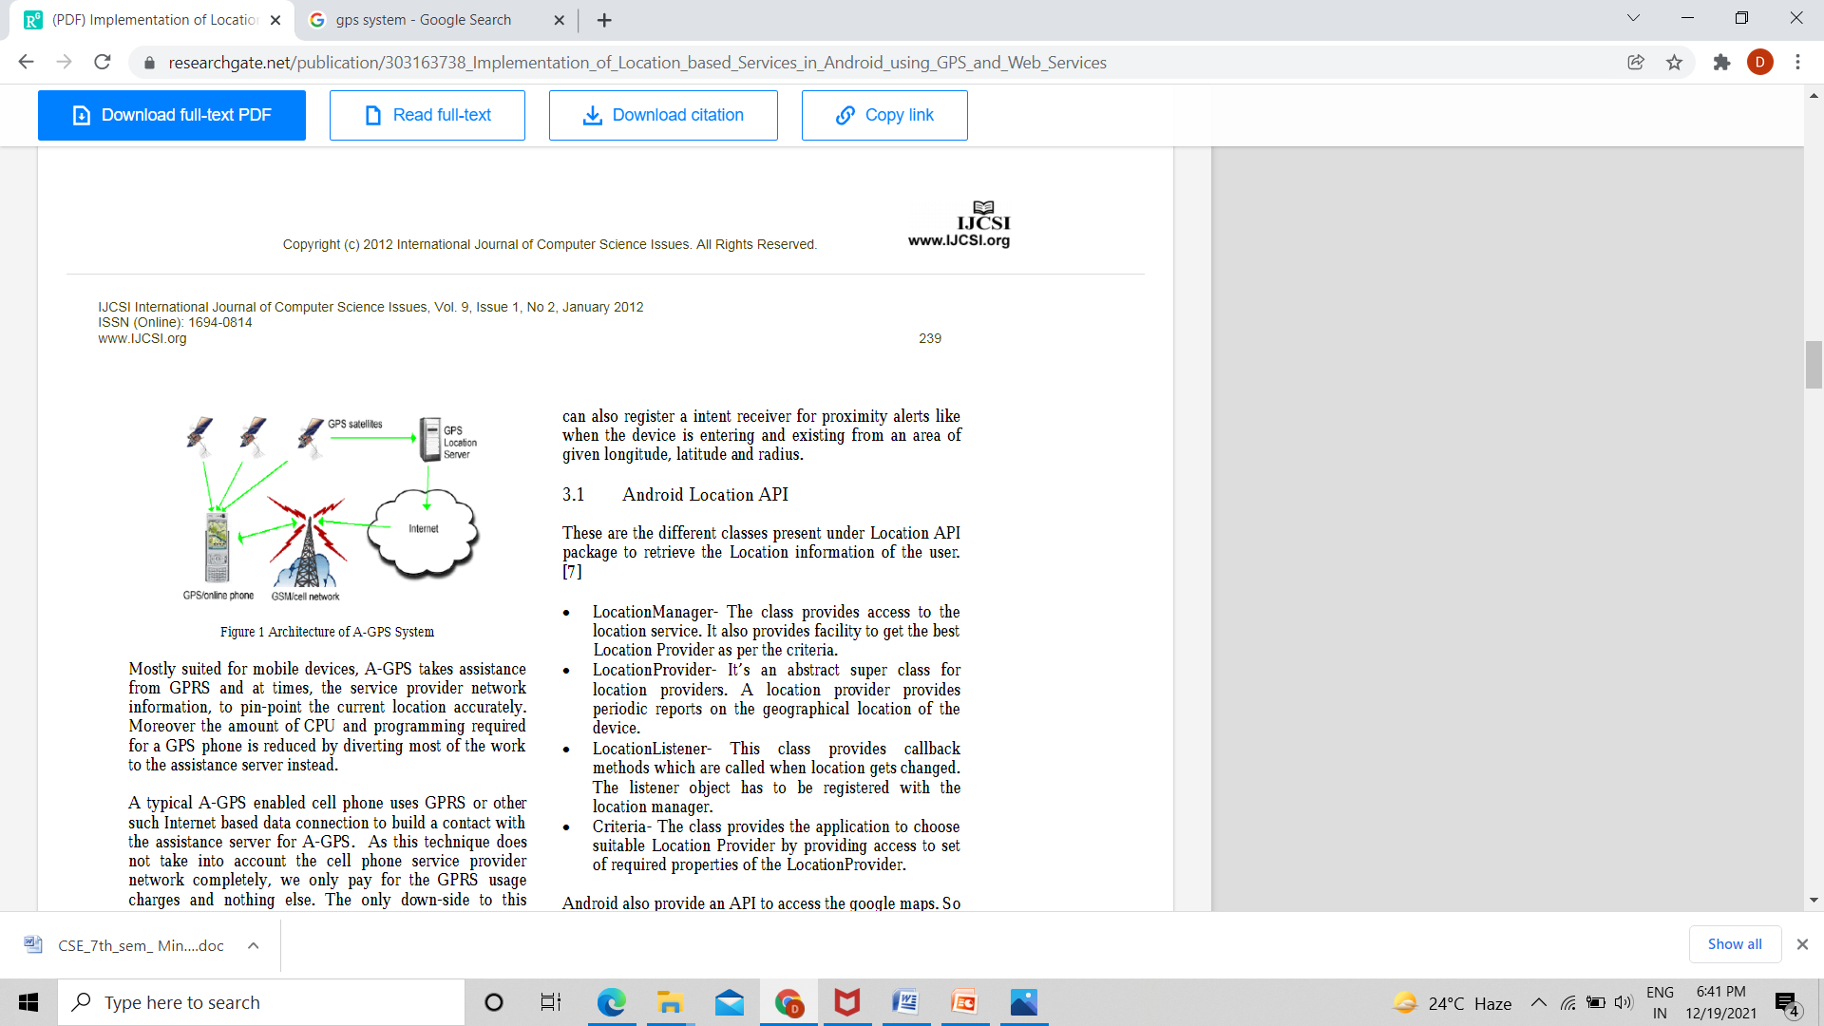

**Android Location API**

These are the different classes present under Location API

package to retrieve the Location information of the user.

• **LocationManager**- The class provides access to the

location service. It also provides facility to get the best

Location Provider as per the criteria.

• **LocationProvider**- It’s an abstract super class for

location providers. A location provider provides

periodic reports on the geographical location of the

device.

• **LocationListener**- This class provides callback

methods which are called when location gets changed.

The listener object has to be registered with the

location manager.

• **Criteria**- The class provides the application to choose

suitable Location Provider by providing access to set

of required properties of the LocationProvider.

Android also provide an API to access the google maps. So

with the help of the google maps and the location APIs the

application can show required places to the user on the

map.

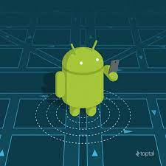

Figure – 2 . Android Location API

**Android phone**

**Android** is a [mobile operating system](https://en.wikipedia.org/wiki/Mobile_operating_system) based on a modified version of the [Linux kernel](https://en.wikipedia.org/wiki/Linux_kernel) and other [open source](https://en.wikipedia.org/wiki/Open-source_software) software, designed primarily for [touch screen](https://en.wikipedia.org/wiki/Touchscreen) mobile devices such as [smartphones](https://en.wikipedia.org/wiki/Smartphone) and [tablets](https://en.wikipedia.org/wiki/Tablet_computer). Android is developed by a consortium of developers known as the [Open Handset Alliance](https://en.wikipedia.org/wiki/Open_Handset_Alliance) and commercially sponsored by [Google](https://en.wikipedia.org/wiki/Google). It was unveiled in November 2007, with the first commercial Android device, the [HTC Dream](https://en.wikipedia.org/wiki/HTC_Dream), being launched in September 2008.

It is [free and open-source software](https://en.wikipedia.org/wiki/Free_and_open-source_software); its source code is known as Android Open Source Project (AOSP), which is primarily licensed under the [Apache License](https://en.wikipedia.org/wiki/Apache_License). However most Android devices ship with additional [proprietary software](https://en.wikipedia.org/wiki/Proprietary_software) pre-installed,[[14]](https://en.wikipedia.org/wiki/Android_(operating_system)#cite_note-14) most notably [Google Mobile Services](https://en.wikipedia.org/wiki/Google_Mobile_Services) (GMS)[[15]](https://en.wikipedia.org/wiki/Android_(operating_system)#cite_note-15) which includes core apps such as [Google Chrome](https://en.wikipedia.org/wiki/Google_Chrome), the [digital distribution](https://en.wikipedia.org/wiki/Digital_distribution) platform [Google Play](https://en.wikipedia.org/wiki/Google_Play), and associated [Google Play Services](https://en.wikipedia.org/wiki/Google_Play_Services) development platform.

**Google Map**

Google Maps is a [web mapping](https://en.wikipedia.org/wiki/Web_mapping) platform and consumer application offered by [Google](https://en.wikipedia.org/wiki/Google). It offers [satellite imagery](https://en.wikipedia.org/wiki/Satellite_imagery), [aerial photography](https://en.wikipedia.org/wiki/Aerial_photography), street maps, 360° [interactive panoramic](https://en.wikipedia.org/wiki/Interactive_panorama) views of streets ([Street View](https://en.wikipedia.org/wiki/Google_Street_View)), real-time traffic conditions, and [route planning](https://en.wikipedia.org/wiki/Route_planner) for traveling by foot, car, air (in [beta](https://en.wikipedia.org/wiki/Software_release_life_cycle#Beta)) and [public transportation](https://en.wikipedia.org/wiki/Public_transportation). As of 2020, Google Maps was being used by over 1 billion people every month around the world.

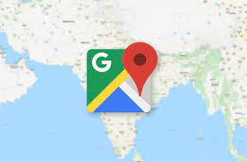

Figure – 3 . Google Map

Chapter – III

(Methodology)

**Java (programming language)**

This project is made in JAVA language .

Java is a [high-level](https://en.wikipedia.org/wiki/High-level_programming_language), [class-based](https://en.wikipedia.org/wiki/Class-based_programming), [object-oriented](https://en.wikipedia.org/wiki/Object-oriented_programming) [programming language](https://en.wikipedia.org/wiki/Programming_language) that is designed to have as few implementation [dependencies](https://en.wikipedia.org/wiki/Dependency_(computer_science)) as possible. It is a [general-purpose](https://en.wikipedia.org/wiki/General-purpose_language) programming language intended to let [programmers](https://en.wikipedia.org/wiki/Programmer) *write once, run anywhere* (WORA), meaning that [compiled](https://en.wikipedia.org/wiki/Compiler) Java code can run on all platforms that support Java without the need for recompilation.

Java applications are typically compiled to [bytecode](https://en.wikipedia.org/wiki/Java_bytecode) that can run on any [Java virtual machine](https://en.wikipedia.org/wiki/Java_virtual_machine) (JVM) regardless of the underlying [computer architecture](https://en.wikipedia.org/wiki/Computer_architecture). The [syntax](https://en.wikipedia.org/wiki/Syntax_(programming_languages)) of Java is similar to [C](https://en.wikipedia.org/wiki/C_(programming_language)) and [C++](https://en.wikipedia.org/wiki/C%2B%2B), but has fewer [low-level](https://en.wikipedia.org/wiki/Low-level_programming_language) facilities than either of them. The Java runtime provides dynamic capabilities (such as [reflection](https://en.wikipedia.org/wiki/Reflective_programming) and runtime code modification) that are typically not available in traditional compiled languages.

As of 2019, Java was one of the most [popular programming languages in use](https://en.wikipedia.org/wiki/Measuring_programming_language_popularity) according to [GitHub](https://en.wikipedia.org/wiki/GitHub), particularly for [client–server](https://en.wikipedia.org/wiki/Client%E2%80%93server_model) [web applications](https://en.wikipedia.org/wiki/Web_application), with a reported 9 million developers.



Figure – 4. Java Logo

**Android Studio**

This project is built in Android Studio version 3.1

Android Studio is the official [integrated development environment](https://en.wikipedia.org/wiki/Integrated_development_environment) (IDE) for [Google](https://en.wikipedia.org/wiki/Google)'s [Android](https://en.wikipedia.org/wiki/Android_(operating_system)) [operating system](https://en.wikipedia.org/wiki/Operating_system), built on [JetBrains](https://en.wikipedia.org/wiki/JetBrains)' [IntelliJ IDEA](https://en.wikipedia.org/wiki/IntelliJ_IDEA) software and designed specifically for [Android development](https://en.wikipedia.org/wiki/Android_software_development). It is available for download on [Windows](https://en.wikipedia.org/wiki/Windows), [macOS](https://en.wikipedia.org/wiki/MacOS) and [Linux](https://en.wikipedia.org/wiki/Linux) based operating systems or as a subscription-based service in 2020. It is a replacement for the [Eclipse Android Development Tools](https://en.wikipedia.org/wiki/Eclipse_(software)#Android_Development_Tools) (E-ADT) as the primary IDE for native Android application development.

Android Studio was announced on May 16, 2013 at the [Google I/O](https://en.wikipedia.org/wiki/Google_I/O) conference. It was in early access preview stage starting from version 0.1 in May 2013, then entered beta stage starting from version 0.8 which was released in June 2014. The first stable build was released in December 2014, starting from version 1.0.

**APK bundle**

An Android App Bundle is **a publishing format that includes all your app's compiled code and resources, and defers APK generation and signing to Google Play**. ... You no longer have to build, sign, and manage multiple APKs to optimize support for different devices, and users get smaller, more-optimized downloads.

Most app projects won’t require much effort to build app bundles that support serving optimized APKs. For example, if you already [organize your app’s code and resources](https://developer.android.com/guide/topics/resources/providing-resources#AlternativeResources) according to established conventions, simply [build signed Android App Bundles](https://developer.android.com/studio/publish/app-signing#sign-apk) using Android Studio or [using the command line](https://developer.android.com/studio/build/building-cmdline), and [upload them to Google Play](https://developer.android.com/studio/publish/upload-bundle). Optimized APK serving then becomes an automatic benefit.

When you use the app bundle format to publish your app, you can also optionally take advantage of [Play Feature Delivery](https://developer.android.com/guide/playcore/feature-delivery), which allows you to add feature modules to your app project. These modules contain features and resources that are only included with your app based on conditions that you specify, or are available later at runtime for download [Using the Play Core Library](https://developer.android.com/guide/playcore).

A variety of frameworks have evolved over the years, each with its own strength and weakness. Each of the available methodology frameworks are best suited to specific kinds of projects, based on various technical, organizational, project and team consideration. In our project I have followed the Incremental process model.

Incremental Process Model:

Incremental Model is a process of software development where requirements divided into multiple standalone modules of the software development cycle. In this model, each module goes through the requirements, design, implementation and testing phases. Every subsequent release of the module adds function to the previous release. The process continues until the complete system achieved.

The various phases of incremental model are as follows:

• **Requirement analysis**: In the first phase of the incremental model, the product analysis expertise identifies the requirements. And the system functional requirements are understood by the requirement analysis team. To develop the software under the incremental model, this phase performs a crucial role.

• **Design & Development**: In this phase of the Incremental model of SDLC, the design of the system functionality and the development method are finished with success. When software develops new practicality, the incremental model uses style and development phase.

• **Testing**: In the incremental model, the testing phase checks the performance of each existing function as well as additional functionality. In the testing phase, the various methods are used to test the behavior of each task.

• **Implementation:** Implementation phase enables the coding phase of the development system. It involves the final coding that design in the designing 15 and development phase and tests the functionality in the testing phase. After completion of this phase, the number of the product working is enhanced and upgraded up to the final system product.

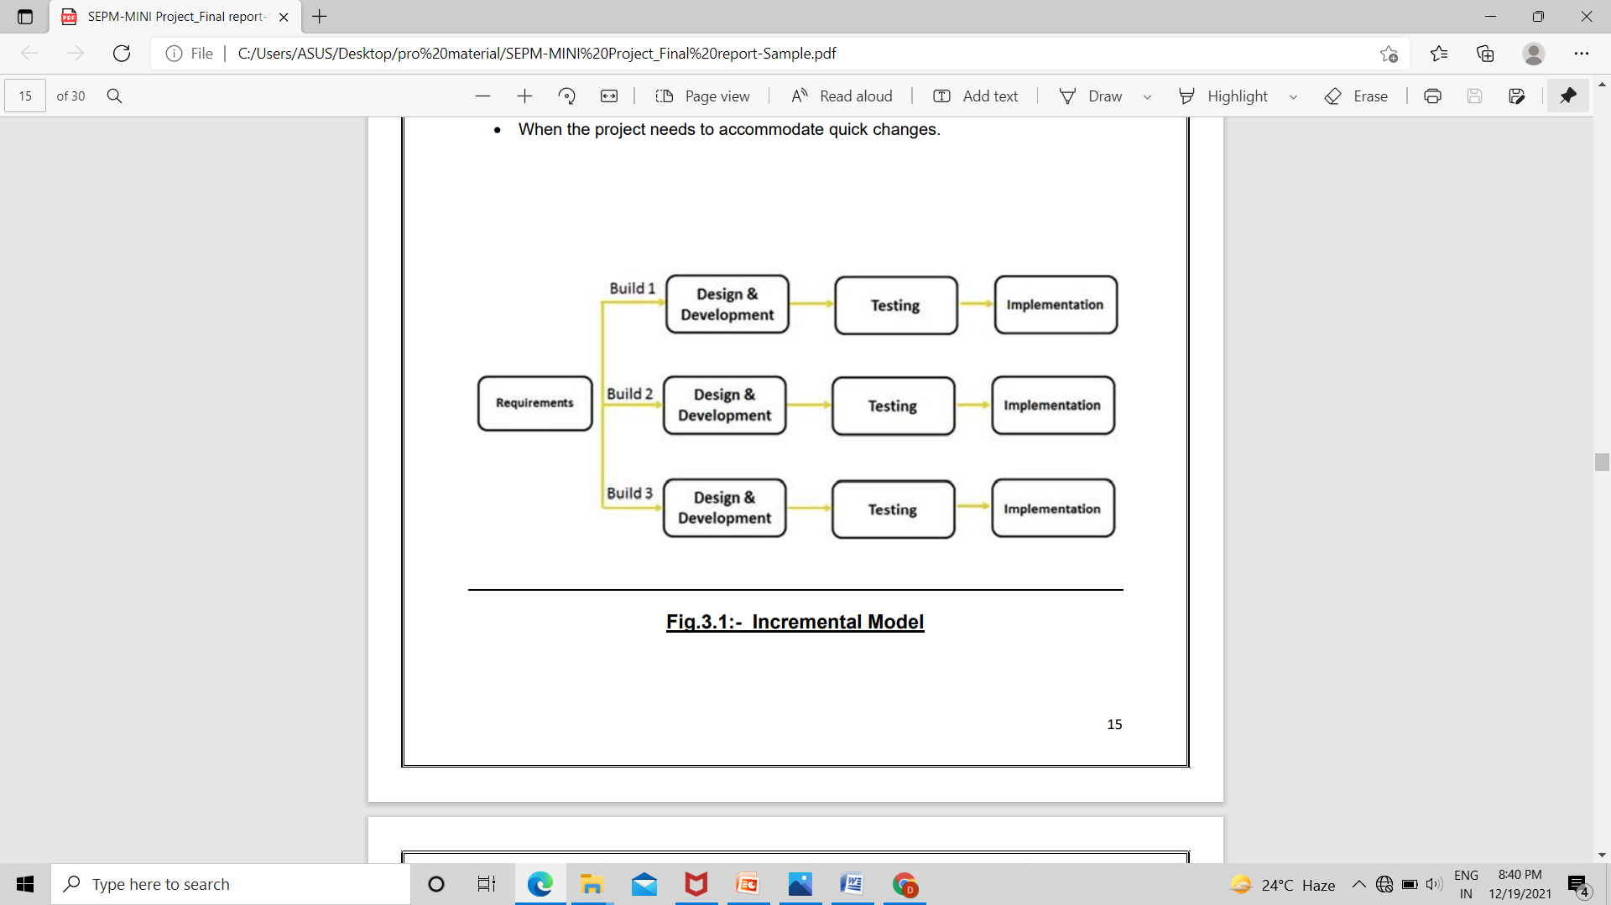

Figure – 5 . Incremental Model

**Software Analysis, SRS**

A software requirements specification (SRS) is a complete description of the behavior of the system to be developed. It includes a set of use cases that describe all of the interactions that the users will have with the software. Use cases are also known as functional requirements. In addition to use cases, the SRS also contains nonfunctional (or supplementary) requirements. Non-functional requirements are requirements which impose constraints on the design or implementation (such as performance requirements, quality standards, or design constraints). Recommended approaches for the specification of software requirements are described by IEEE 830-1998. This standard describes possible structures, desirable contents, and qualities of a software requirements specification.

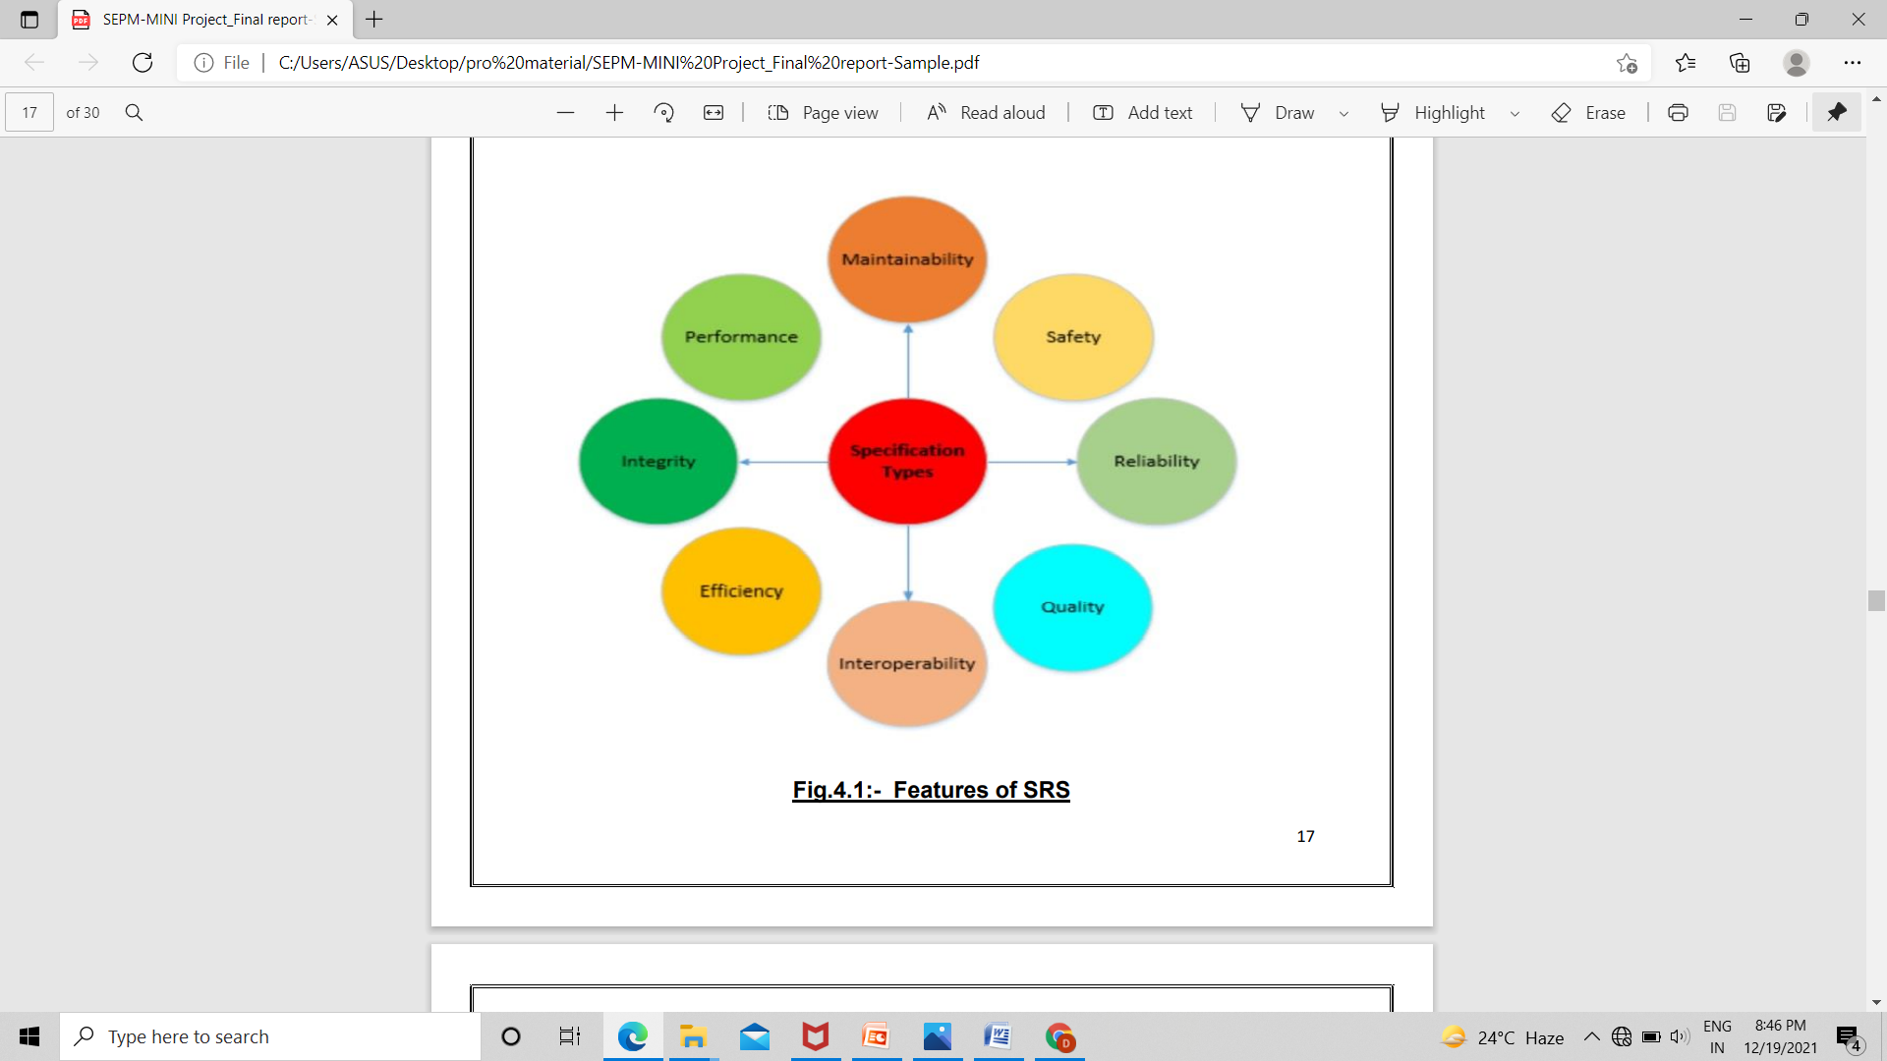

Figure – 6 . Features of SRS

Chapter IV –

( Project Requirements )

**Developer’s End**

* Software Required :
  + - Windows 10
    - Android Studio
* Hardware Required :
  + - Processor – i3 or more
    - Hard Disk – 250 GB
    - Memory – min 2GB RAM
    - In short a computer or laptop.

**End User**

* Software Required :
  + - Windows 10 if using in system
    - Android version minimum 4.1 or more , if using in phone
    - Internet Connection

* Hardware Required :
  + - An android smart phone

**Chapter V –**

**( Diagrams )**

1. WORK FLOW DIAGRAM

A workflow diagram is a visual representation of a business process (or workflow), usually done through a flowchart. It uses standardized symbols to describe the exact steps needed to complete a process, as well as pointing out individuals responsible for each step. The “workflow” as we know today can be traced back to two American mechanical engineers, Henry Gantt and Frederick Wilson Taylor. Both were known for their contributions towards the development of scientific management .

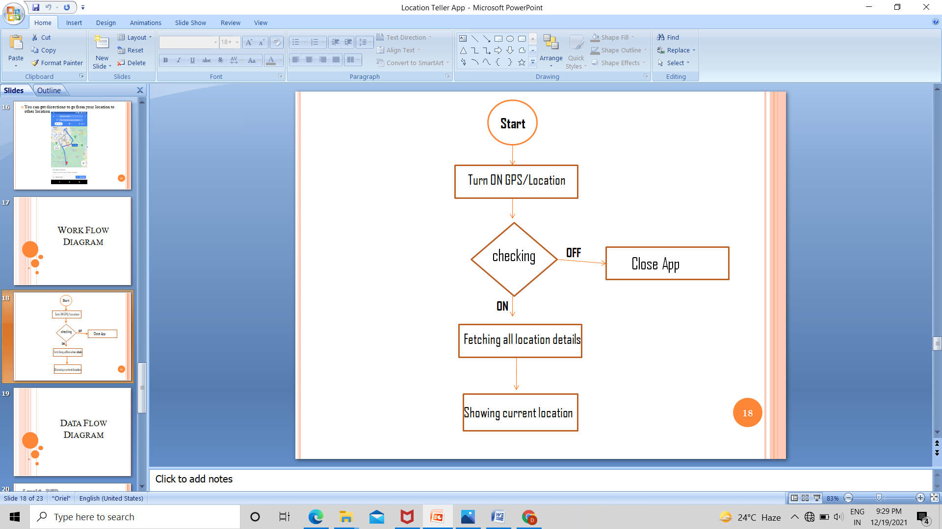

1. Data Flow Diagram

Data flow diagrams are used to graphically represent the flow of data in a business information system. DFD describes the processes that are involved in a system to transfer data from the input to the file storage and reports generation.

Data flow diagrams can be divided into logical and physical. Data flowcharts can range from simple, even hand-drawn process overviews, to indepth, multi-level DFDs that dig progressively deeper into how the data is handled. They can be used to analyze an existing system or model a new one.

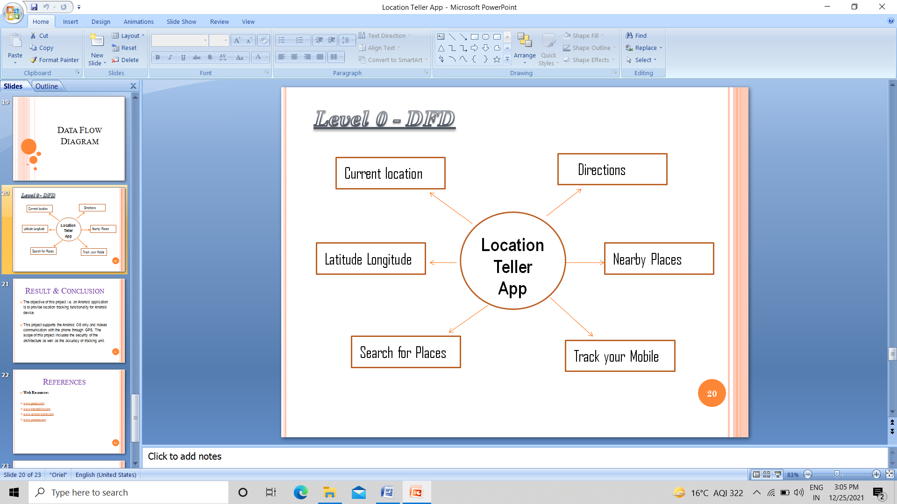

Chapter – VI

( Snapshots of the project )

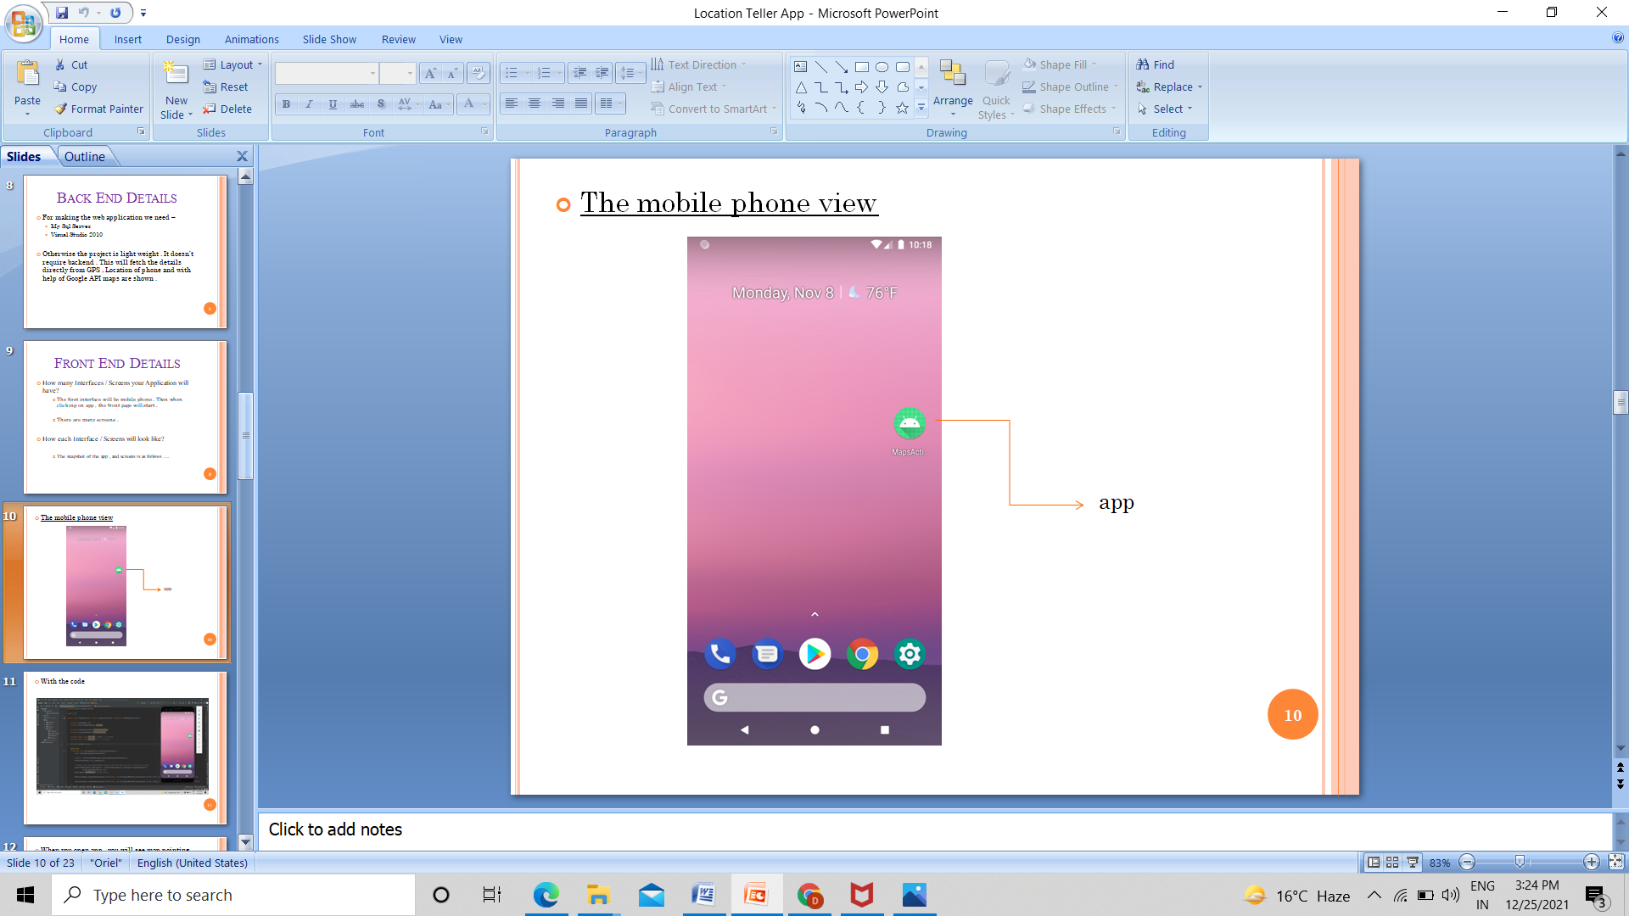

Figure – 9 . App View

With code –

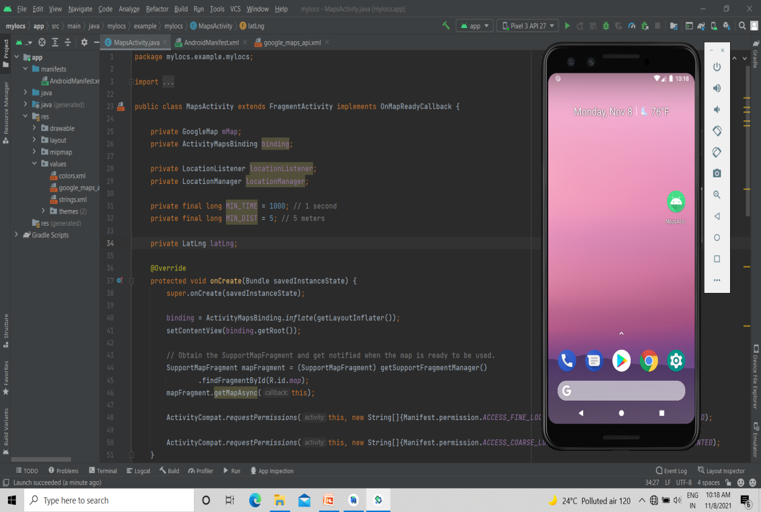

Figure – 10 .

* When you open app , you will see map pointing your current location ie, where you are .

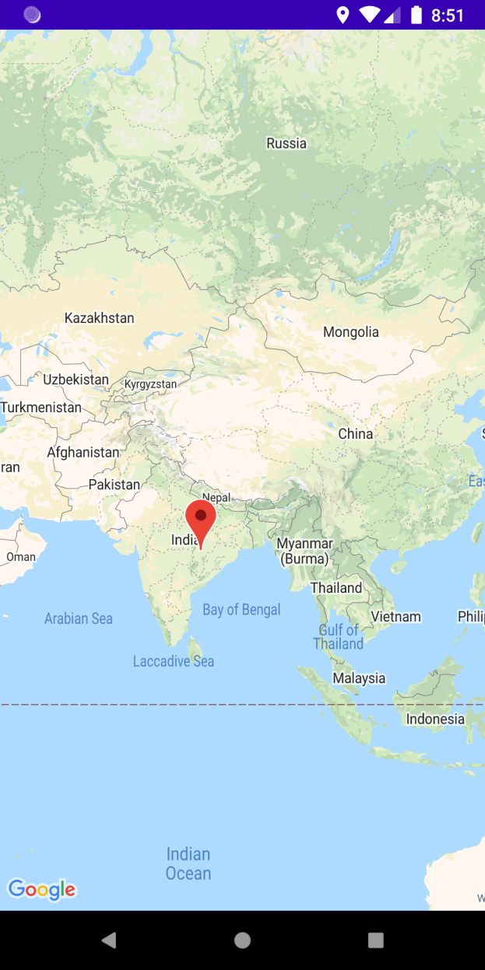

Figure – 11 .

* When you click or touch the pointer it will display the name of that particular place .

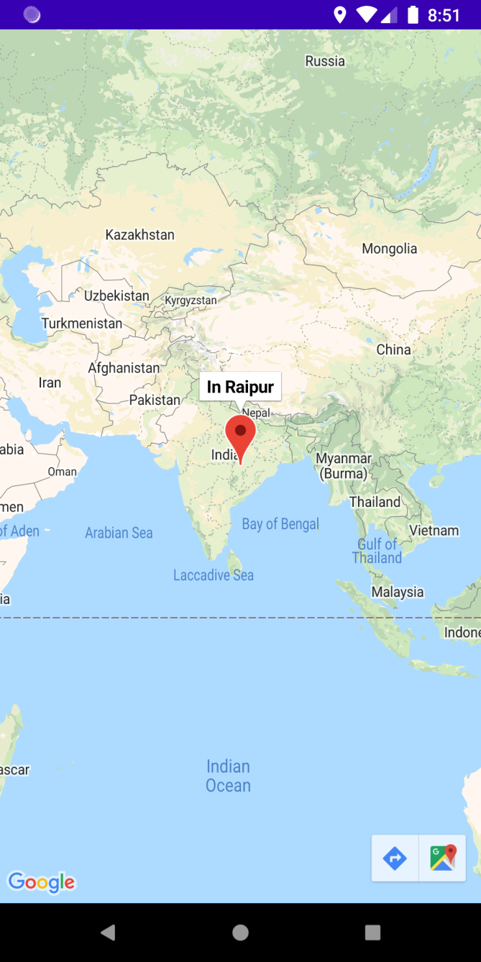

Figure – 12 .

* You can also search for places …

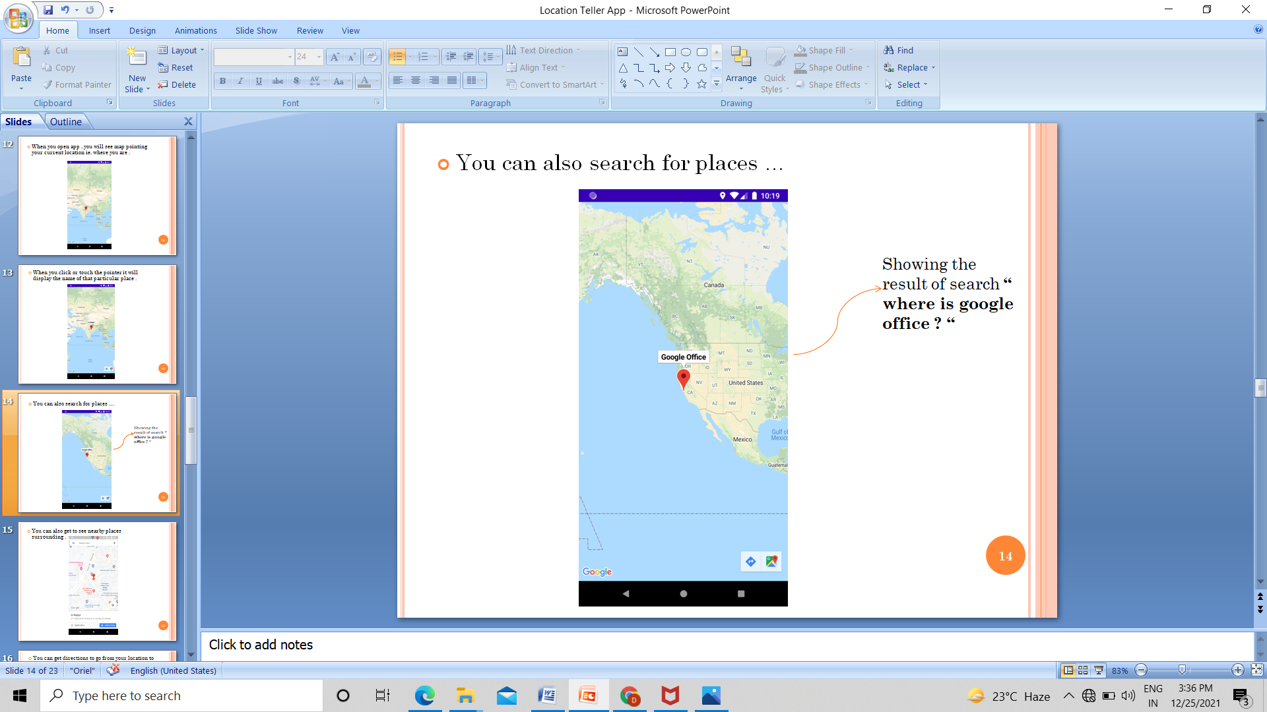

Figure – 13 .

* You can also get to see nearby places surrounding .

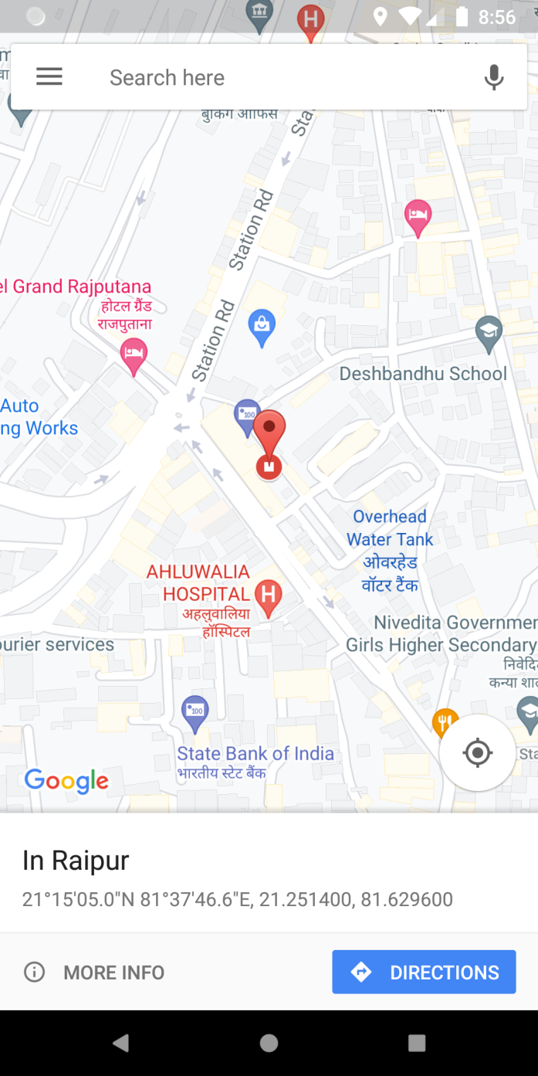

Figure – 14 .

* You can get directions to go from your location to other location .

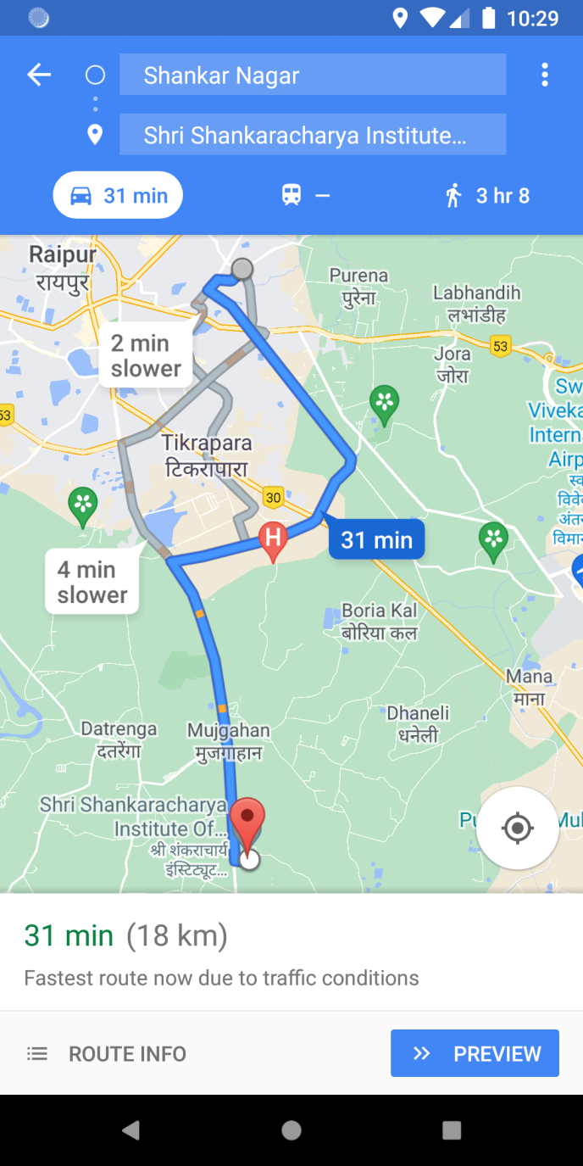

Figure – 15 .

Chapter – VII

( Results , Future Scope , References )

Result

The objective of this project i.e. an Android application is to provide location tracking functionality for Android device.

Conclusion

This project supports the Android OS only and makes communication with the phone through GPS. The scope of this project includes the security of the architecture as well as the accuracy of tracking unit.

**Future Scope**

Right now this app is simple . It tells the current location of the android handset .

In future this project will cover larger scope . As this app tells the current location , so it can be developed for security purpose . The user must create login id and then if in case his / her mobile phone gets lost then using login id password in we application he / she will be able to track the position of the mobile phone .

**Limitation**

This project is little simpler . No big frame works are there . To access this app one must always enable the GPS location ON into the device . Just for location purpose , the internet is not required but for all other navigation purpose internet is required . This project right now does not store data , further advancement is required for storing the user details for getting access in web application .

**References**

* **Web Resources**
* [www.google.com](http://www.google.com/)
* [www.thecodecity.com](http://www.thecodecity.com/)
* [www.nevonprojects.com](http://www.nevonprojects.com/)
* [www.youtube.com](http://www.youtube.com/)

**Paper Publication**